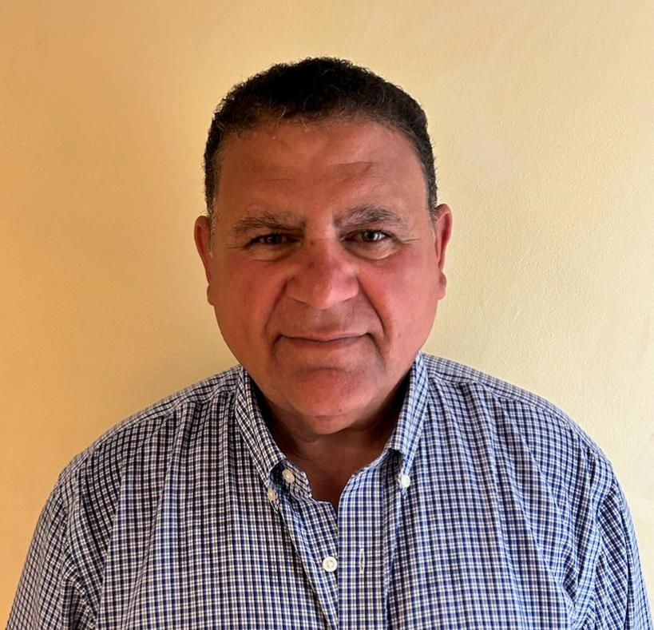
EDUCATION
BSME, University of New Haven, 1987

PROFESSIONAL REGISTRATION/CERTIFICATION
NICET Level IV: Highway Construction
NICET Level 1: Bridge Safety / Water-Wastewater / Building Construction
ACI- Grade 1: Concrete Field Testing
NETTCP: Concrete Inspector/HMA Paving Inspector/ Soil & Aggregate Inspector/ Density Gauge Operation
FHWA: Federal Highway NBIS (National Bridge Inspection Standards)
ATSSA: TSC- Traffic Control Supervisor & TCT - Traffic Control Technician
OSHA 10- Construction Safety

EXPERIENCE SUMMARY
Mr. Al-Jamal possesses considerable construction engineering experience acquired from his employment with the New York City Department of Design and Construction as a Construction Inspector, Resident Engineer, and most recently, as Engineer-In-Charge. His oversight of multiple infrastructure projects in Manhattan and the Bronx gave him challenges in dealing with the safety issues of heavy construction in a very densely populated environment including the maintenance and protection of both vehicular and pedestrian traffic. He is well-versed in all aspects of construction including adherence to plans, specifications and testing requirements.

Connecticut Department of Transportation (CTDOT), Auxiliary Lanes, Resurfacing, and Safety Improvements on I-95, Stamford, CT – Senior Inspector for the $60 million construction of additional lanes along I-95 between exits 6 and 7. He is responsible for supervising a team of inspectors responsible for the quality control of all aspects of the project including, illumination, excavation, bridge structure jacking and modification, concrete pavement repairs, bituminous concrete paving, maintenance and protection of traffic, noise wall installation, drainage installation, rock and earth excavation, median replacement and installation of Traffic Management System facilities.

Engineer-In-Charge
Connect Shafts 24B, 25B, 27B, 30B to System Trunk Water Mains - MED 609 ($35M) - October 2022 to November 2022
Trunk Water mains in W 30th St Phase 2 - MED 598B ($27M) - October 2022 to November 2022
Vesey Street Reconstruction - HWMWTCB6 ($7M) - October 2022 to November 2022
Reconstruction of simple and complex pedestrian ramps adjacent to historic and/or landmark areas - HWP15XMCL ($5.3M) - May 2022 to Present
Reconstruction of complex pedestrian ramps adjacent to transit authority - HWP15XMTA - ($7.5M) - May 2022 to Present
Reconstruction of Nassau St from Pine St to Maiden Lane - HWMWTCB1 ($6.5M) - December 2022 to Present
Reconstruction of Trinity Place - HWMWTCB7 ($37.5M) - November 2023 to Present
Prior Notice Sidewalks in the Bronx - City Owned Property - HWS2021X ($1.5M) - October 2023 to Present
Prior Notice Sidewalks in the Bronx and Manhattan ($2M) - HWS2021XM - October 2023 to Present
Replacement of Distribution Watermains on 7th Avenue between 14th St and 34th St - MED 669 July 2022 to Present (Design Phase)
Safe Routes to School Manhattan - HWCSCHPMN (Design) - July 2023 to Present

Resident Engineer
Reconstruction of Forsyth Plaza HWPLZ008M ($3.5M) - September 2017 to June 2018
Reconstruction of Simple Pedestrian Ramps HWPR18M ($6.9M) - March 2019 to July 2019
Reconstruction of simple and complex pedestrian ramps adjacent to historic and/or landmark areas HWP15XMCL ($5.3M) - July 2019 to May 2022
Reconstruction of complex pedestrian ramps adjacent to transit authority HWP15XMTA ($7.5M) - July 2019 to May 2022

Field Inspector
Safe Routes to School HWSCH3B2 ($6M) - September 2016 to September 2017
Bogardus Plaza Reconstruction HWPLZ012M ($4M) - June 2018 to October 2018
Accelerated Distribution Water Main and Sewer Replacement MEDA-003 ($16.7M) - October 2018 to March 2019

